Mathematics for AI
Course Code: MEAD-603
Lab File

Submitted to: Mr. Rahul Mishra

Submitted by
Manav Gosain

in partial fulfillment for the award of the degree
of
Master of Technology - AI/DS


Center for Development of Advanced Computing, Noida
Affiliated to Guru Gobind Singh Indraprastha University

Index
S. No. | Title | Page No.
1. | Write a program to take a matrix as input and transpose it within the matrix | 1
2. | Write a program to take 2 matrices as input and find their product
3. | Write a program to solve a system of equations using gauss elimination method
4. | Write a program to solve a system of equations using gauss jordan method
5. | Write a program to find the inverse of a matrix

Q1. Write a program to take a matrix as input and transpose it within the matrix

n = int(input("Enter the dimension of matrix: "))

matrix = []

# input matrix elements
for i in range(n):
rows = []
for j in range(n):
value = int(input(f"Enter the {i}{j} element of the matrix: "))
rows.append(value)
matrix.append(rows)

# print original matrix
print("\nOriginal matrix:")
for row in matrix:
print(row)

# swap the non diagonal elements
for i in range(len(matrix)):
for j in range(i):
matrix[i][j], matrix[j][i] = matrix[j][i], matrix[i][j]

# print modified matrix
print("\nTransposed matrix:")
for row in matrix:
print(row)

Sample Output 1:
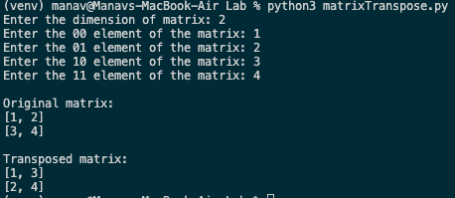

Sample Output 2:
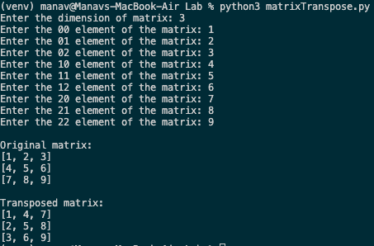

Sample Output 3:
